 **STUDY GUIDE I : Reading and Listening 4tht Year**

**Teacher: Mr. Cristián Marchant Huerta** [**cmact66@gmail.com**](mailto:cmact66@gmail.com)

I. Listen to the Audio and answer:

1. Which city did the virus come from?
2. Beijing b) Wuhan c) Shanghai
3. When was the corona virus family first identified?
4. in the 1960s b) in the 1980s c) in 2019

3.What does “zoonotic disease” mean?

1. conditions that can be passed from animals to humans.
2. conditions that can be passed from humans to animals.
3. conditions that can be passed from humans to humans.

4.Where did the virus first start?

1. in vegetable market in China
2. in the Huanan seafood wholesale market
3. in a pet shop in China

5.What are the main symptoms?

1. dry cough, mild fever, and breathing issues
2. wet cough, mild fever, and breathing issues
3. dry cough, high fever, and breathing issues

6.What part of the body does the virus affect?

1. Stomach b) Heart c) Lungs

7. Who is more at risk of Coronavirus?

1. The youth b) Older people c) Babies

8. What treatment is available?

1. Antibiotics b) cough medicine c) no treatment

|  |
| --- |
| 1. Fever |
| 1. Treatment |
| 1. Outbreak |
| 1. Cough |
| 1. Crucial |
| 1. Disease |
| 1. Transmit |
| 1. Zoonotic disease |

**II. Match the words to their meaning / Relaciona los significados**

1. suddenly starts to happen
2. extremely important
3. conditions that can be passed from animals to humans
4. an illness which affects a person
5. pass something from one person to another
6. suddenly push air out of your throat with a short sound
7. a very high temperature
8. something that is done to cure someone who is ill

**III. Fill in. Use the words above. Complete usando los términos anteriores**

**1**. mild ……………………. **2.** ………………………. disease **3.** …………………………..of the disease **4.** dry……………………. **5.**……………………….. question **6.** no …………………….for it is available so far **7.** zoonotic…………………….. **8** .………………………… through direct contact

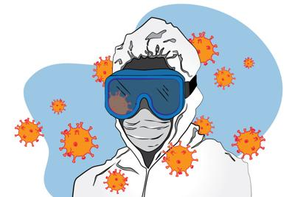

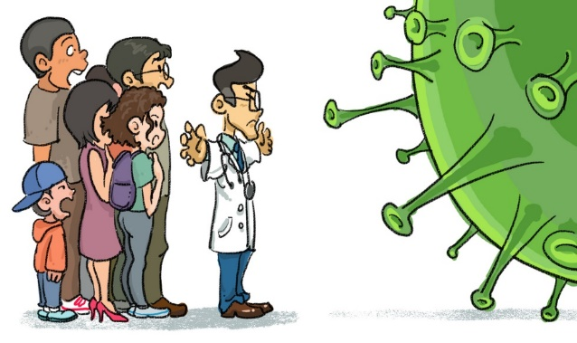

**IV. Read the text and fill in the gaps 1-5 with a correct sentence A-E. One sentence is extra. Lee el texto y complete con una oración correcta de las letras A a la F (una sobra)**

By now, most of us are aware of the outbreak of the disease started in Wuhan, China, caused by a new species of virus called Novel Coronavirus. They belong to a member of the Corona virus family that was first identified in the 1960s.

But the crucial question is, how did the recent outbreak occur? Well, like other Coronaviruses, it has come from animals too and is a form of zoonotic disease. Many of those infected patients either worked or frequently shopped in the Huanan seafood wholesale market in the centre of the Chinese city, which sells meat and live animals. It is believed that the virus might have been transmitted through direct contact between human and animals either by touching those animals or consuming them, and it can also spread via the air like other cold-causing viruses.

But what we know so far is its symptoms and how it effects humans. Yes, a person infected from this disease may suffer from dry cough, mild fever, and breathing issues, which may go unnoticed at first.

Also, it is believed that these viruses are more likely to infect older people and those with a weak immune system that find it hard to fight these notorious viruses. But, is there any way to treat this disease?

Now, here comes the most crucial question, what can we do to stop this outbreak?

Also, it would be best if you wash your hands with warm and soapy water regularly, especially, after being in direct contact with an infected person.

**A**. Well, unfortunately, all this is very new illness, no treatment for it is available so far, and because it is a virus, antibiotics won’t work against it.

**B.** They are responsible for causing a range of diseases in humans, including the common cold and more severe and life-threating forms like SARS and MERS.

**C.** But, as the virus spreads its legs inside the person’s body, the patient might develop a severe case of viral pneumonia, an infection that inflames the air sacs in the lungs and can cause them to fill with fluid or pus and need immediate medical attention.

**D.** The virus is named after its shape, which takes the form of a crown with protrusions around it and hence is known as Coronavirus

**E.** However, unfortunately the actual source of this disease isn’t confirmed yet, and scientists are still trying to figure it out.

**F.** Well, it is always advisable to practice good hygiene and caution by avoiding close contact with individuals suffering from acute respiratory infections, or wild animals or livestock, dead or alive.

V. ACTIVITY : Write sentences related to the images.

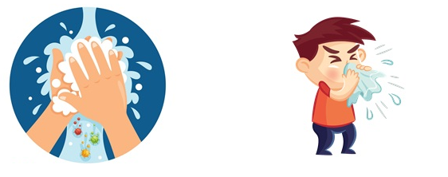

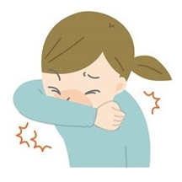

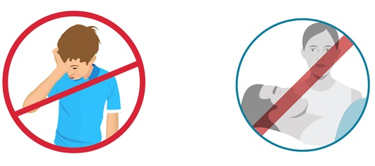

Answers

IMPORTANT: For evaluation purposes, send photos with your answers to [cmact66@gmail.com](mailto:cmact66@gmail.com)